Notícias:
19.06.2017 - 1º Encontro dos Clientes do GSAN 3.0
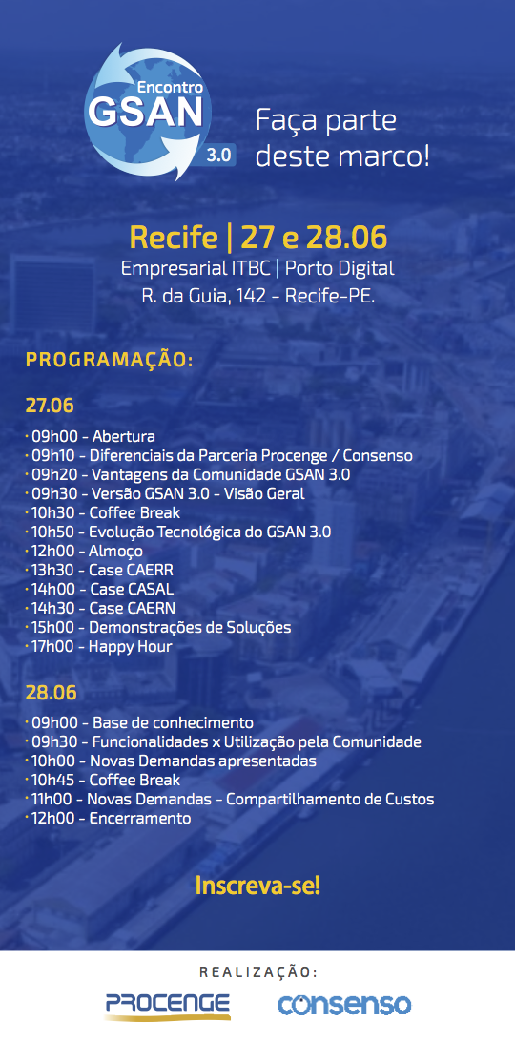

03.05.2017 - Lançamento do GSAN na versão JBoss AS - Wild Fly
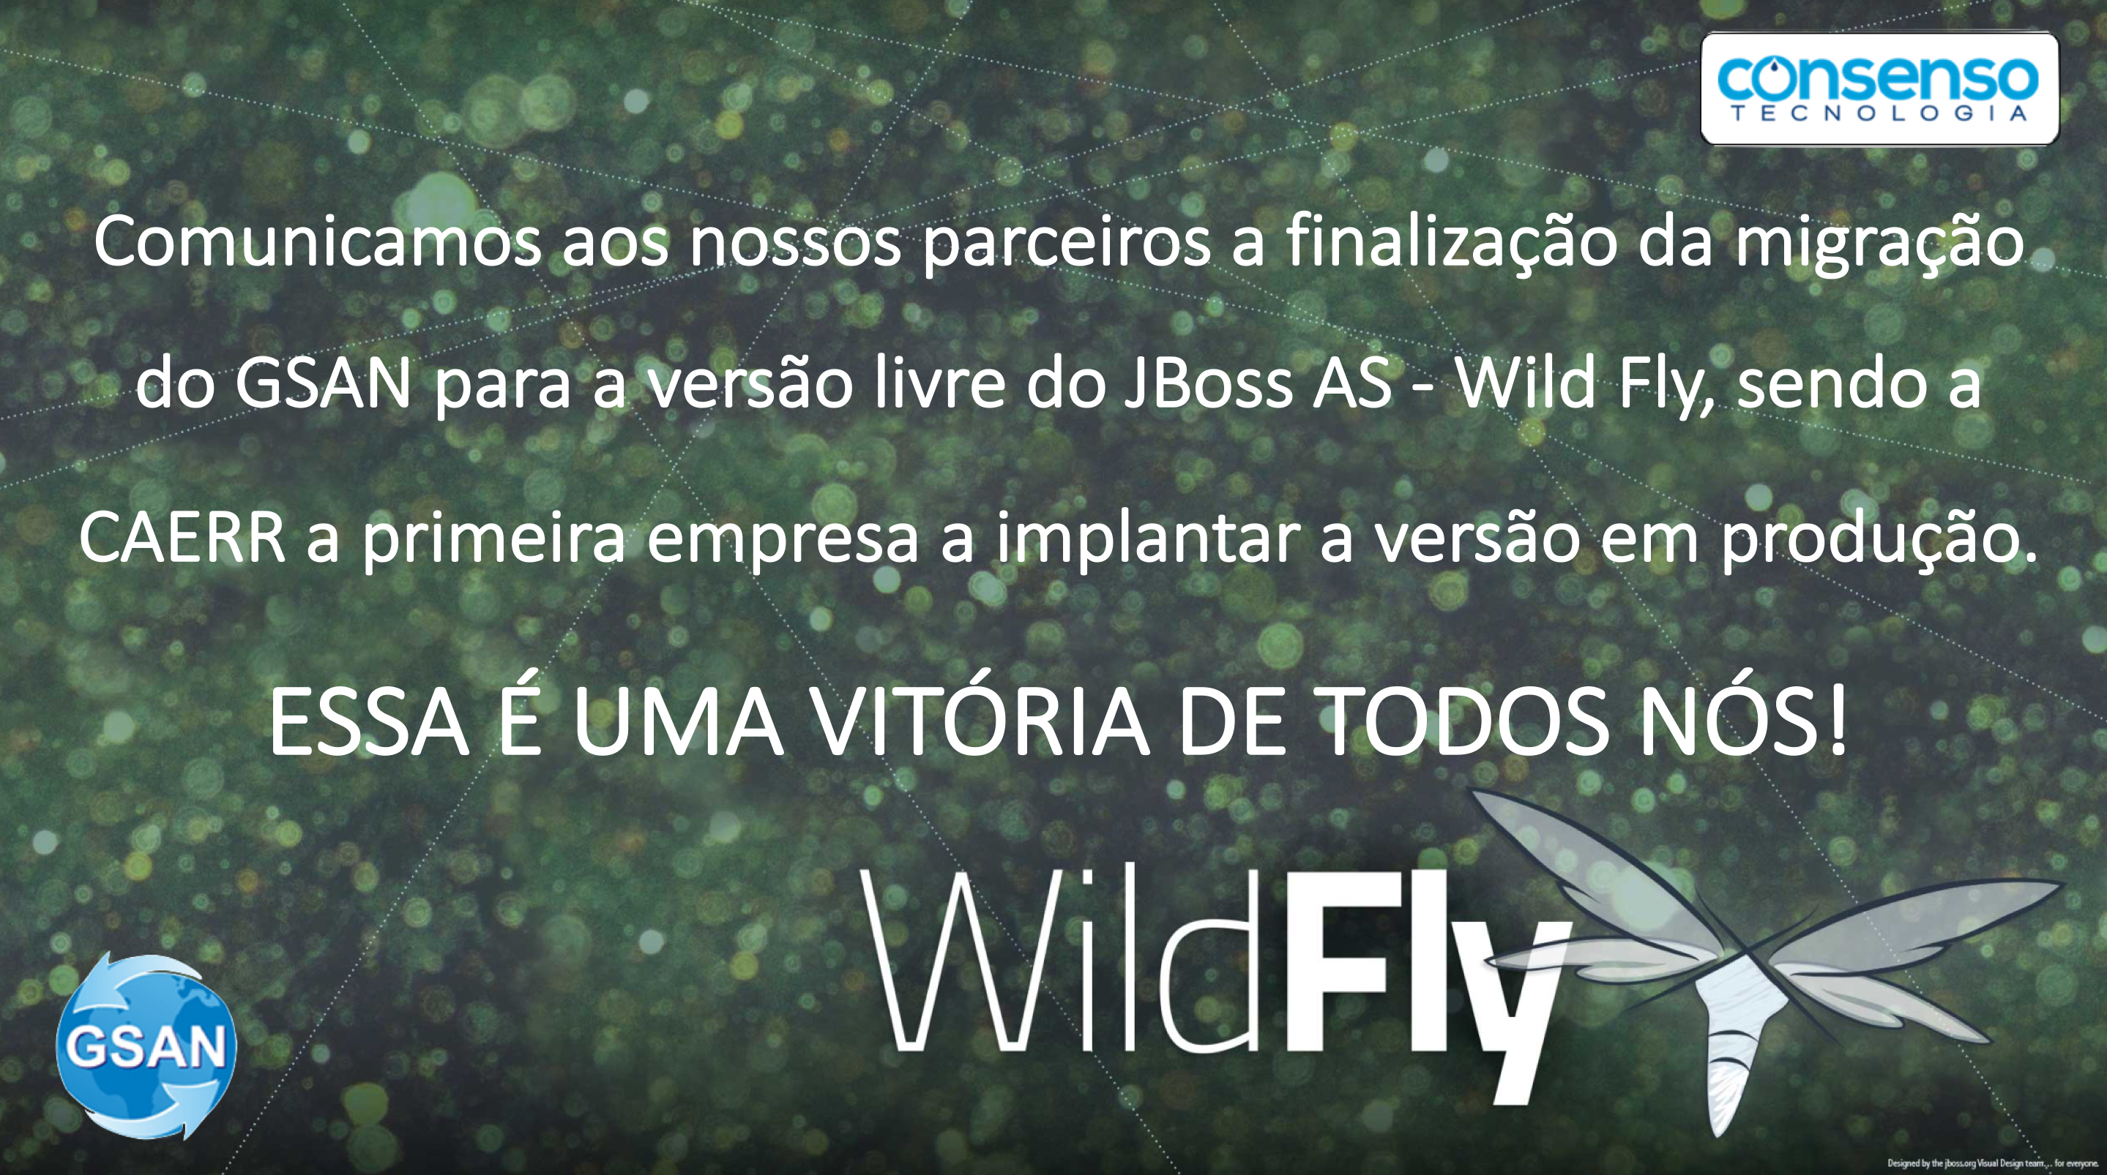

Outras Notícias
- Anthropic Asks Christian Leaders for Help Steering Claude's Spiritual Development
- Sam Altman's Home Targeted a Second Time, Two Suspects Arrested
- Robot Birds Deployed by Park to Attract Real Birds - Built By High School Students
- Has the Rust Programming Language's Popularity Reached Its Plateau?
- How Good is Windows on Arm With Snapdragon X?
- 'Super Mario Galaxy Movie' and 'Project Hail Mary' Combine for Best Box Office in 7 Years
- Hisense's New Backlit RGB LED TV 'a Shot Against OLED's Bow', and Includes a DP Port
- Botched IT Upgrade Ended Liquor Sales for the Entire State of Mississippi

